CSC 7135 Group project

**AN ONLINE JOB SEARCH PLATFORM**

**First Scrum**

Date : 02/10/2020

Team B

|  |  |  |  |  |
| --- | --- | --- | --- | --- |
| **Guangyuan Dai** | **Mahfuza Khatun** | **Kaitlyn Madden** | **San Chu** | **Edward Wilson** |
| gdai1@lsu.edu | mkhatu1@lsu.edu | kmadde5@lsu.edu | schu2@lsu.edu | ewils53@lsu.edu |

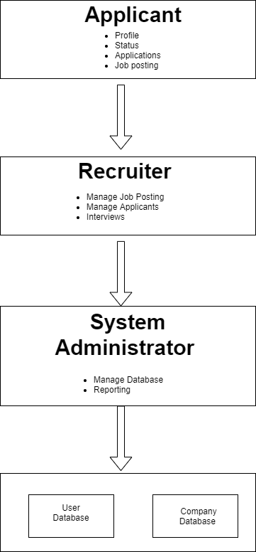

Figure: Project Architecture.

**Include a Backlog image here!**

DCDR.sa- oil and gas association (over 100 companies) from Texas

Creating an online job search platform for these companies as well as other "in the area"

**User Requirements:**

Permits Applicant (Employee and Non-employee) to-

* Create a profile with important information (i.e. personal information and areas of interest).
* Submit resume and other documents.
* Subscribe email notification about latest positions and possible matches
  + Matches identified using textual analysis among the job descriptions, areas of interest.
* Filter according to number of positions available, salary, state/region, qualifications.
* Receive job suggestions of other jobs that match with an applied one.
* Have a page where applicants can see their list of applications.
  + Shows status of applications (*received/reviewed/denied/approved/closed*).
  + Withdraw or discard their application.
  + Edit application information until the due date.

Employee Applicants can:

* + Request recommendations letter from supervisor
  + Access system with job identification number (*that means we'll need unique numbers across all companies*)
  + See some jobs specified only for them

Allows System Administrator to-

* Keep track of Available positions
* Keep track of Active applications
  + Prioritize applications of current/former employees
* Update the status of applications (*accepted/denied/finished/in progress*)
  + Jobs that are filled should be taken off the list of open positions
* Present all jobs according to most relevant and newer positions
* Differentiate between employee and non-employee

Authorize Recruiters to do the following-

* Filter suitable applicants by matching key words (education level, experience level, etc.) from resumes uploaded to the system.
* View application details (such as, the number of applications in each job position.).
* Send reminders about upcoming interviews.
* Keep it "organized" by showing a list of "outstanding" candidates and the status of their application.
* Add, remove and Edit job information.

**System requirements:**

* Online
* Includes a database that keeps track of all applicants and open positions
* Information about internal and external applications
* Verifies that applicants only apply to job once
* Applications cannot be overwritten
* No applications accepted after due date
* System can only accept 100 applications per job
* Some positions are only for current employees
* Applicants can apply to max of 50 jobs at a time
  + Must go in and remove themselves from closed positions
* Once job is filled
  + send an email notification to all applicants
  + Changed to "FILLED'
* Generates a monthly report including-
  + List of current employee applying to open positions
  + Percentage of current employee that got a new job
  + List of non-employees applying to open positions
  + Percentage of non-employee that got a new job
  + Area/field receiving the highest number of applications
  + Filled position with the highest number of applications

**Questions/assumptions:**

* *Should the administrative report be company specific or whole of DCDR.sa?*
  + *Who is getting admin report?*
  + *How often is the report generated and sent?*
* *How do we want to handle when companies are looking for more than 1 applicant for a position?*
* *Quantify what an "outstanding applicant" is.*
* *What does the job posting process look like?*
* *What area/companies are we covering exactly?*
  + *Are employees of one company considered for openings in “employee only” positions of another company?*
  + *Is it just Texas?*
* ***System requirement:***
  + *Do we want to add for it to automatically remove after a week of being filled?*
  + *A lot we can add to this report*
    - *Positions that are having difficulty filling/don't fill by deadline*
    - *Salary posted vs. salary accepted*
    - *If a position opens more than once a year/positions that open more than twice in 5 years*
* ***User requirement:***
  + *Do we need a system administrator as a single person, who will have special authorities in the system controlling, or each company will have their own representative to do the job?*
  + *If we have a system administrator then, what are his responsibilities?*
  + *If we have System Administrator, do the companies still need to deal directly with the website, or the Administrator can do everything on behalf of them?*